Indra Ratna

Katrina Mae Paredes

Ethan Yao

CS-UY 3083

Professor Katz

Intro to Databases: PhotoStore

**End User Documentation**

1. **Index**

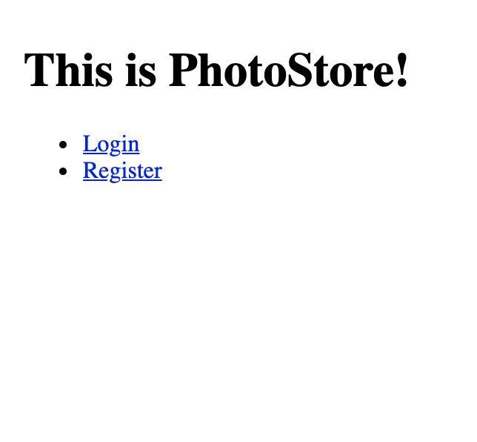The index is the first page a user is led to when they want to use PhotoStore. They must either register as a new account or login to an existing account.

1. **Registration**

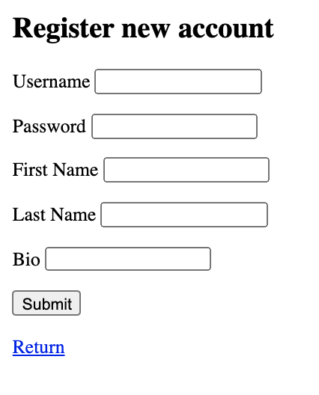

This page is used to create a new member account for PhotoStore. You must enter a username, password, and bio. The username must not already exist on PhotoStore.

1. **Login**

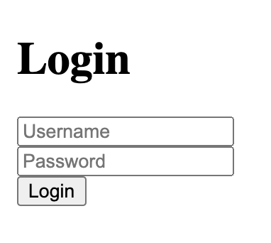

Login page takes the username and password created during registration in order to access the account. Users will be notified if they enter an invalid username and/or password at which point they will be told to try again. If login is successful they will be moved to the welcome page.

1. **Welcome Page**

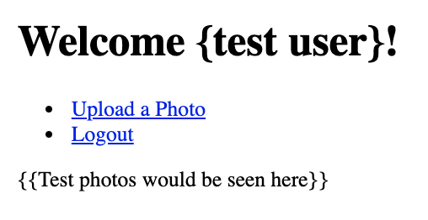

After successful login a user can then choose from this welcome page menu for actions to do with their account. They are welcomed based on their username. If logout is clicked the user will be redirected to the index page. All photos on PhotoStore can be found on this page, here you can also click on a photo to view its details.

1. **Logout**

If logout is selected the user will be redirected to the index page

1. **Uploading a photo**

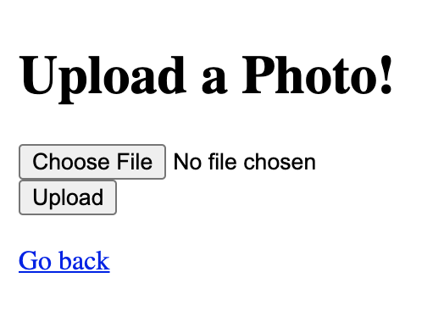

In this feature a user can add a photo onto their account. First they must click the ‘choose file’ button and then the ‘upload’ button to finish the action of adding the photo.

1. **Thumbs Ups & Comments**

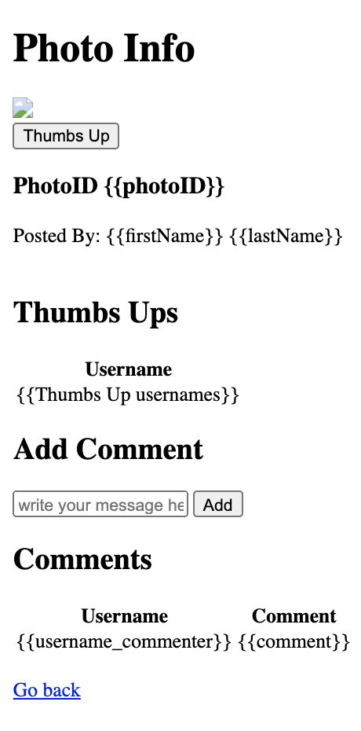

By clicking the ‘thumbs up’ button, users can add a thumbsup reaction to any photo they choose. Then their username will show up under the username table within ‘ThumbsUp info’. If they would like to comment, they can enter a comment in the textbox under ‘Add Comment’. Then by selecting the ‘add’ button their comment is saved.